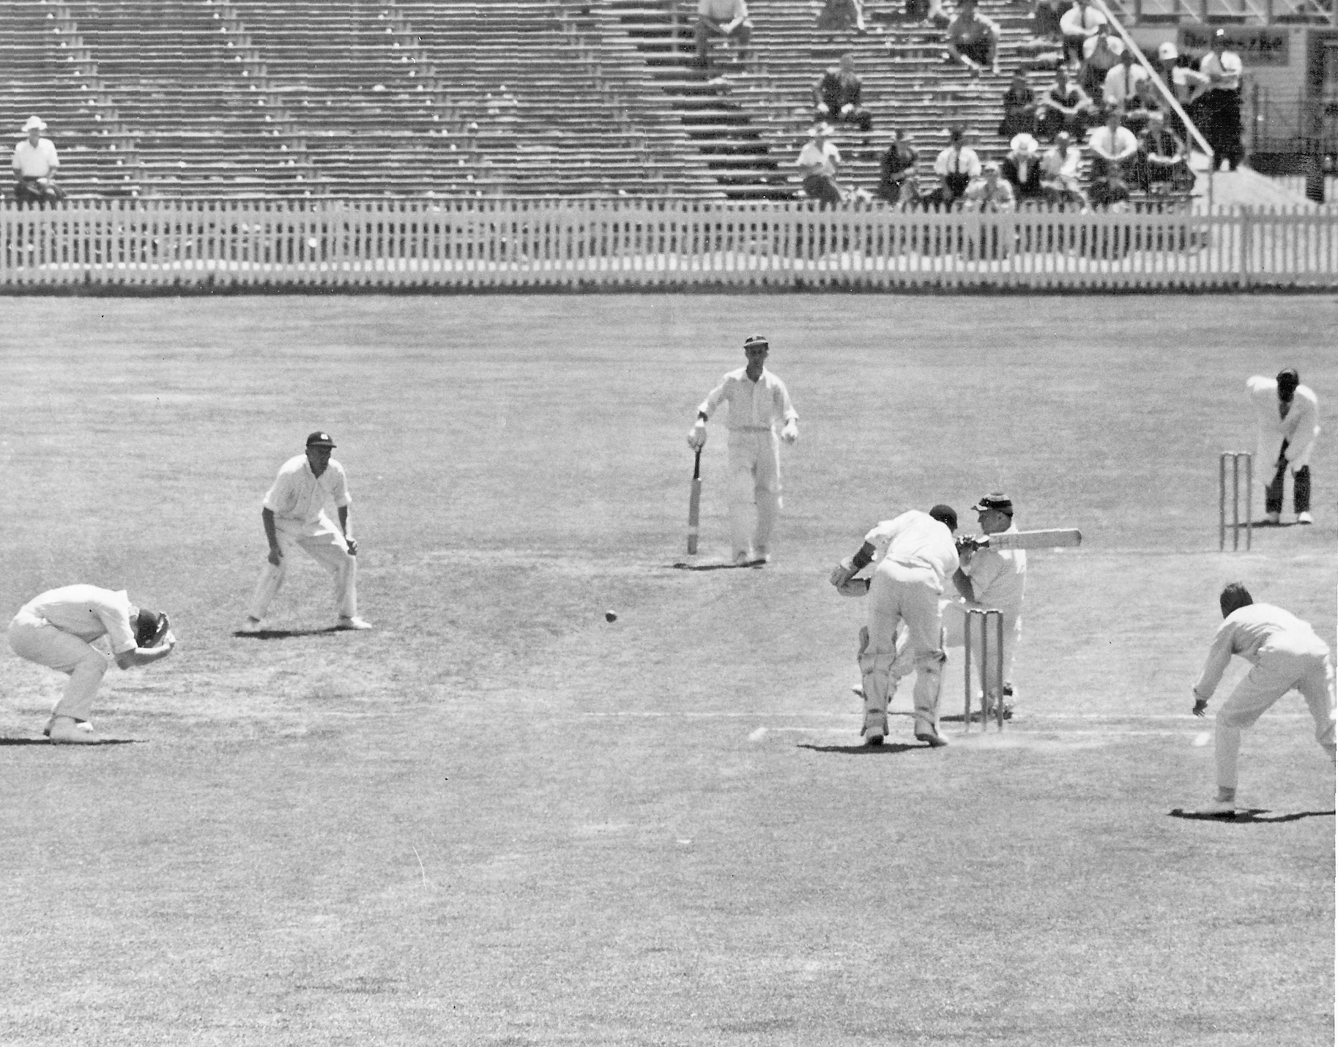

**Canterbury against MCC touring team Lancaster Park 7 January 1961**

**K Thomson sweeping BA Bolton non striker JT Murray wicket keeper**

**Canterbury 287 and 190. MCC 288/3 declared and 190/9 MCC won by one wicket**